Module 3: Homework 3: Create a dataset and table, then load data into the table in BigQuery.

* Steps I took to create a dataset.
  + Open the BigQuery page in the Google Cloud console.   
    > Go to the Google Cloud console > Look for the BigQuery tab >
  + In the Explorer panel, select the project where you want to create the dataset.
  + Expand the Actions option and click Create dataset.
  + On the Create Dataset page:
    - Dataset ID > I enter a unique dataset name, “babynames.”> Select the region.
  + Click Create dataset.

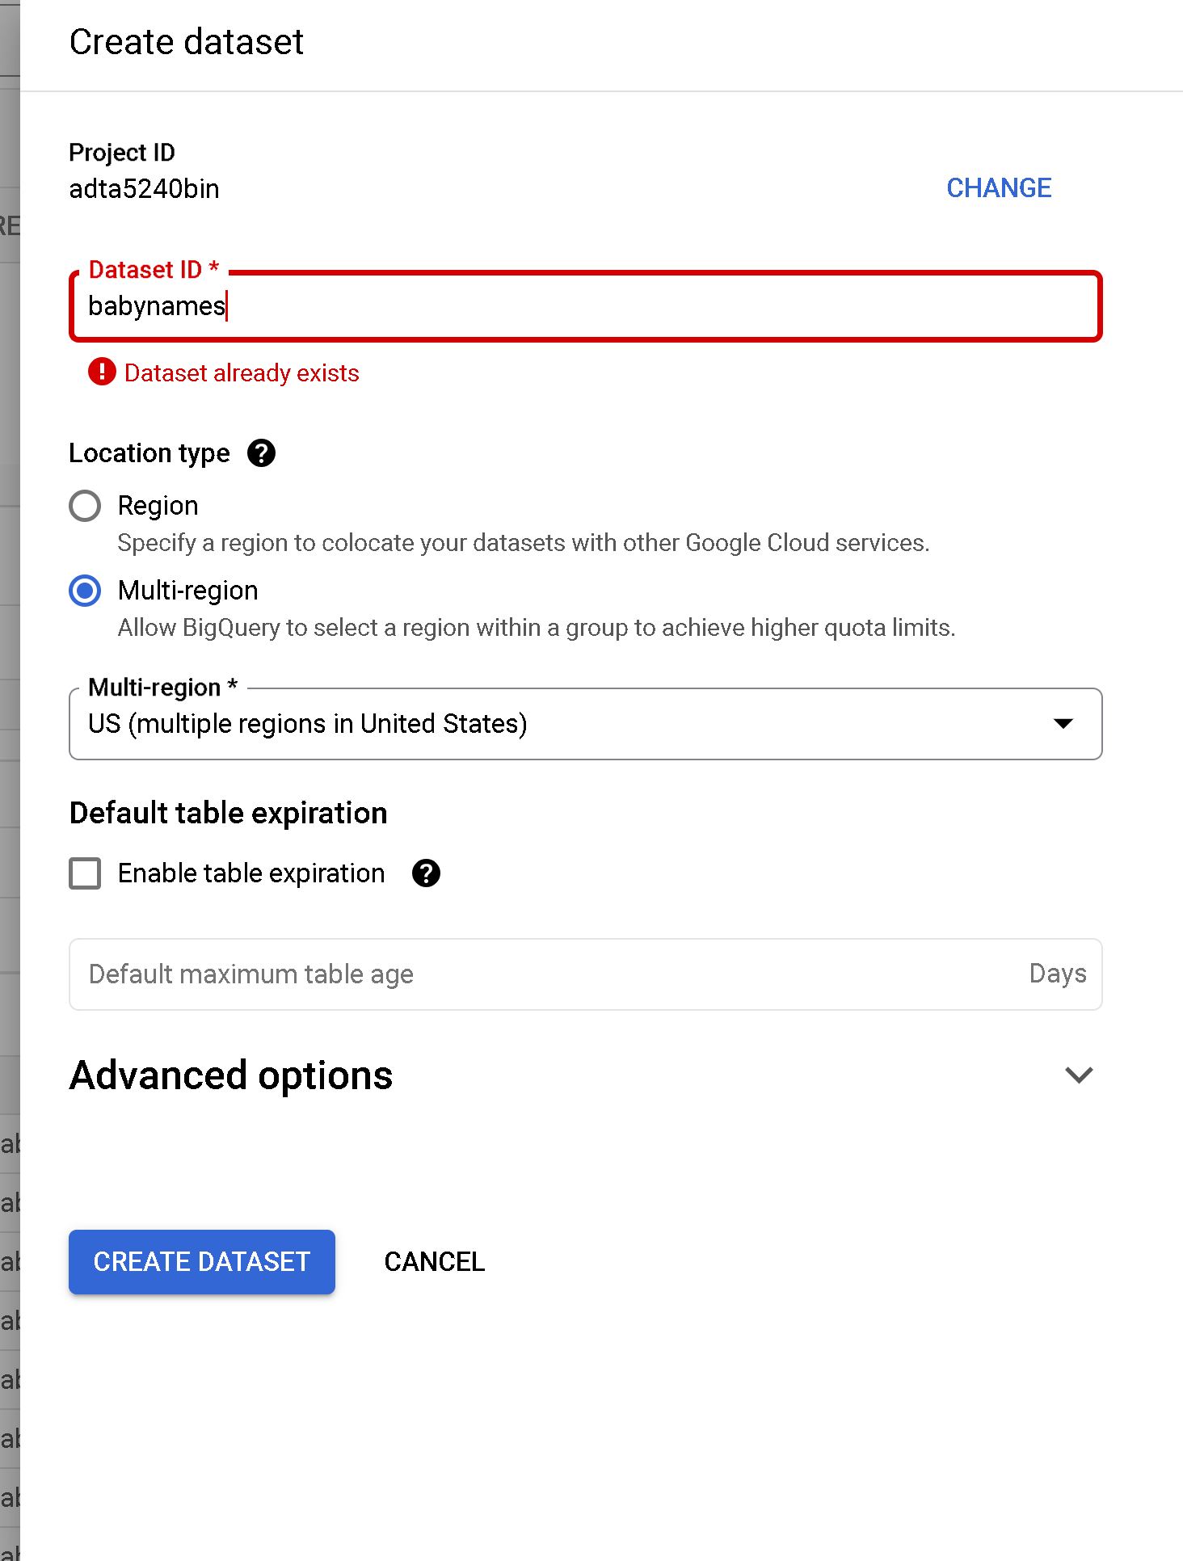

* Steps I took to create a table and load the data.
  + Select a dataset.
  + Dataset info section ellipse, click Create table.
  + Create table panel,
    - Source section, select Upload > Select File > and pick CSV as file type
  + Destination section
  + Table field > Name_20214.
  + Verify that the Table type field is set to Native table.
  + Schema section > Click Edit as text and add name:string, gender:string, count:integer
  + Create table.

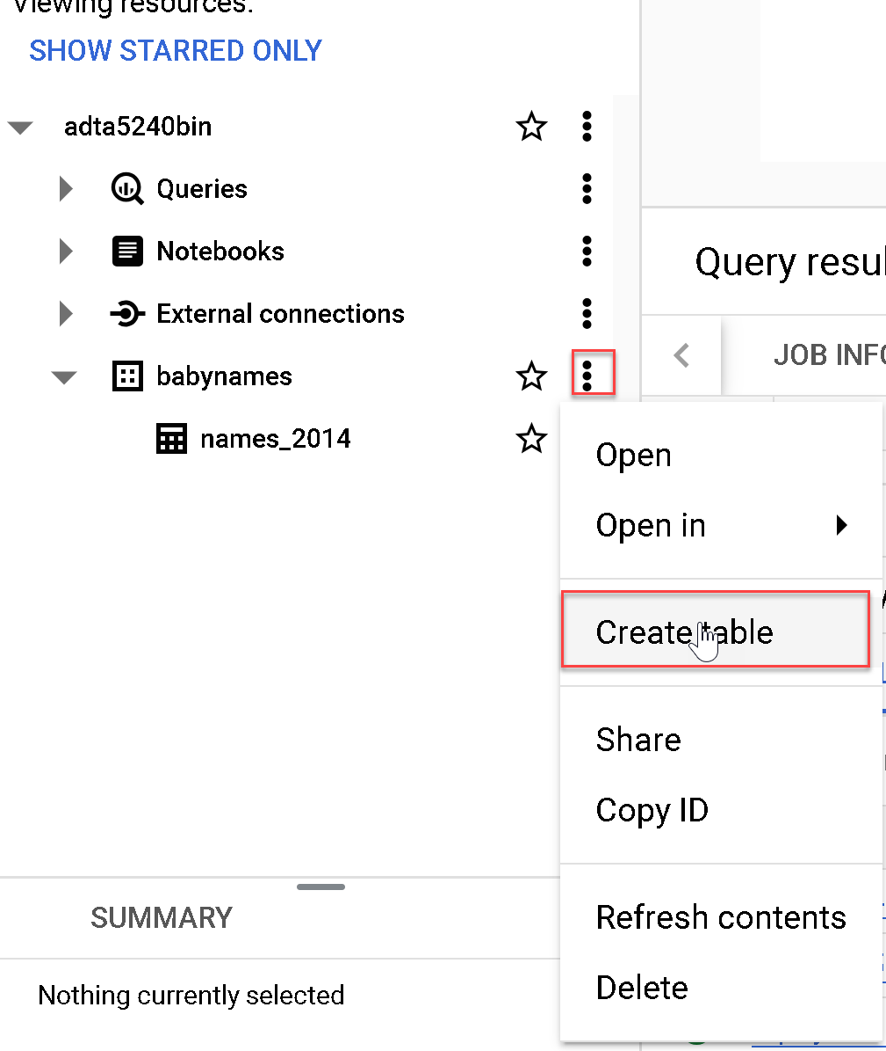

* Steps I took to preview the table
  + Open Query window and I previewed the table by running the following query:

SELECT* FROM `adta5240bin.babynames.names_2014` LIMIT 1000

